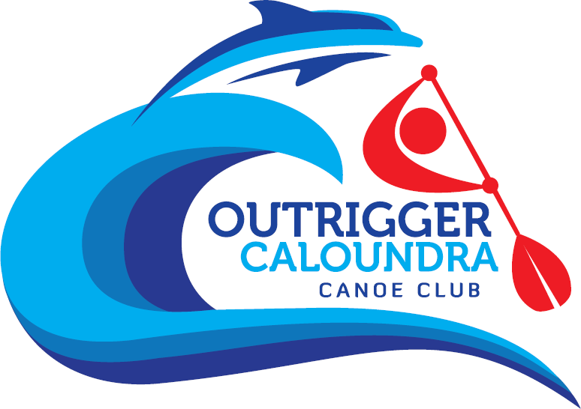Outrigger Caloundra Canoe Club

P.O. Box 226 Golden Beach QLD 4551 [www.occc.com.au](http://www.occc.com.au/)

'Respect for the ocean and its elements, our canoes and our fellow paddlers'

|  |  |  |  |  |  |  |  |  |  |
| --- | --- | --- | --- | --- | --- | --- | --- | --- | --- |
| **MEMBERSHIP APPLICATION** | | | | | | | | | |
| **Personal Details** | | | | | | | | | |
| Name: |  | | | | | | Zone Reg No: |  | |
| Address: |  | | | | | | | | |
| Suburb: |  | | State: | |  | | Postcode: |  | |
| e-mail: |  | | | | | | | | |
| Mobile: |  | | Home Phone: | |  | | Occupation (optional only): |  | |
| **Other Information** | | | | | | | | | |
| **It is your responsibility to ensure your AOCRA details are kept up to date. In the event of an emergency we will refer to their website for further detail.**  Have your suffered from any medical conditions over the past 12 months? **Yes No (please circle)**  If yes, please discuss with OCCC Management Committee/Coaching Team and provide brief details (such as asthma, heart condition, etc) below.  You may be required to acquire a medical certificate for your membership to be accepted. | | | | | | | | | |
| **Medical Condition(s)** | | | | | | | | | |
|  | | | | | | | | | |
|  | | | | | | | | | |
|  | | | | | | | | | |
| Do you have a current coaching certificate in any other sport? | | |  | **Yes** | **No** | Do you have a current QLD Blue Card? | | | **Yes No** |
| Are you a Level 1 Specific Outrigging Coach? | | |  | **Yes** | **No** | Do you have a current QLD Boat Licence? | | | **Yes No** |
| Do you agree to your details being used for publication? | | |  | **Yes** | **No** | Do you have a current First Aid Certificate? | | | **Yes No** |
| Do you agree to your phone number being provided to other club  members? | | |  | **Yes** | **No** |  | | | |
| **Appproval Signatures** | | | | | | | | | |
| Once you have paid your club membership and your AOCRA insurance is current, the information herein provided will be processed and your membership application assessed providing you acknowledge that you continue to be bound by the following agreement:  **PLEASE READ BEFORE SIGNING**  In signing below, I hereby acknowledge that I have read and consent to being bound by the AOCRA Indemnity Agreement and abide by the Rules, Code of Conduct, Directions and Constitution of AOCRA Inc and Outrigger Caloundra Canoe Club Inc. I accept the terms, exclusions, conditions and limitations of Arthur J. Gallagher Injury and Legal Liability Insurance Contract and I have read and understand the AOCRA Anti-Doping Policy as published at [www.aocra.com.au.](http://www.aocra.com.au/) I agree that all fees are non-refundable and I will assist with the running of the club by helping with the loading and unloading of canoes, rigging and de-rigging, washing of covers and general maintenance of the equipment and shed as required. I accept that any personal belongings stored in the club shed or transported on club trailers (including OC1s, V1s and other personal craft) are not covered by OCCC insurance policies. I accept the club's Risk Management Policy and agree to abide by club policies.  If I fail to abide by the policies therein, I indemnify Outrigger Caloundra Canoe Club Inc and hold it harmless against any liability, damage, cost or expense arising out of or in connection with any failure on my part to adhere to the risk management assessment and its attachments. Copies can be obtained from the OCCC Secretary as required and the club website.  I agree to assist in club activities, such as open days, corporate days, fundraising activities, beginner programs and the hosting of regattas. Penalties may apply to members who consistently train, race and use club equipment yet fail to help with a fair share of club activities.  **□ I have read the risk management plan provided by Outrigger Caloundra Canoe Club Inc.**  **My signature below acknowledges that I agree unconditionally to accept the aforementioned terms.** | | | | | | | | | |
| **Renewal Process Completed Signatures** | | | | | | | | | |
|  | | | | | | | | | |
| Applicants  Signature |  |  | Date: |  |  | Club Registrar  Signature: |  | | Date: |
| **Please Note**: AOCRA insurance is not the same as club membership. The renewal date for your insurance may be different from 1st July and it is your responsibility to ensure your  insurance is current. Failure to do so will result in voiding your OCCC & AOCRA memberships and insurance. Until rectified, you cannot train or race in OCCC equipment or make any claims resulting from an accident or injury. You can check your insurance status by going to [www.aocra.com.au.](http://www.aocra.com.au/) | | | | | | | | | |
| **Membership Fee** | | | | | | | | | |
|  | |  | **Date of Payment:** | | |  | | **Amount**  **Paid:** |  |
| **Payment Methods** | | | | | | | | | |
| **Payable to: Outrigger Caloundra Canoe Club Inc.** | | | | | | | | **YOUR OCCC MEMBERSHIP EXPIRES EOFY** | |
| **Internet**  **Pay Anyone Transfer To:** | | **Account Name** | | | **BSB No.** | **ACCOUNT No.** | |
| **Outrigger Caloundra Canoe Club** | | | **124-038** | **23155734** | |
| Please provide a copy of your Internet Payment Receipt with this Membership Application. | | | | | | | |