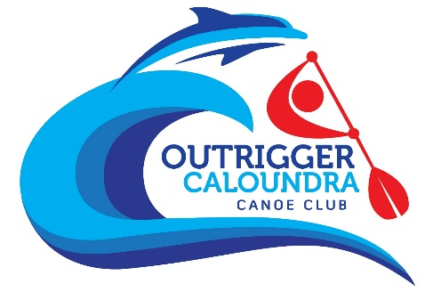
Introduction to Outrigger Canoeing
3 Week Program - October 2021
Information and Registration Form

Thank you for signing up! We are sure this is going to be an exciting, fun and challenging program for you. The information below provides some basic information on what you can expect and what you should bring along.

When:
3 Saturday morning sessions on October 16th, 23rd & 30th @ 9:15am

Where:
Short St, Golden Beach, Caloundra. Parking available at the boat ramp or along The Esplanade.

Outline of the Program:
You will be taken through the traditions, art, skill and safety elements of paddling an outrigger canoe. Each sessions will include a short distance paddle to Bribie Is.

What to expect week to week:
Week 1
- Meet existing club members and program participants.
- Learn the basic technique of paddling and identify safety issues.
- Discuss canoe etiquette.
- Listen to a huli procedure.

Week 2
- Learn about the roles and responsibilities of sitting in seats 1 through to 6.
- Learn about the history of outrigger canoeing and where the sport can take you today.
- Practice getting in and out of the canoe on the water.

Week 3
- Practice “race starts”.
- Participate in training drills you would expect to do in a club session.

Cost:
$50 for three weeks. We’ll send you an invoice to confirm your registration upon the return of this completed form.

What to Bring:
Hat, clothes you don’t mind getting wet, towel for your car, water bottle, water/surf booties or reef shoes (optional to protect your feet from cuts and marine bites on and around the boat ramp). The club will provide the paddles.

What happens after the program:
If you fall in love with outrigger canoeing you are welcome to join the club. Club membership for your first year is $110. Because you are participating in this program, we’ll contribute the $50 you have already paid towards this fee. This subsidised rate is in place to help you purchase your own paddle. You will also need to join the Australian Outrigger Canoe Racing Association (AOCRA) which is our governing body and costs $70 per year.

Our current club training times are:
- Tuesday and Thursday afternoon at 4:30pm
- Tuesday and Thursday mornings at 5am
- Saturday mornings at 7am

Contact:
P: Bec 0439 342 807 or Tracy (Lulu) 0411 827 888
E: occcsec@hotmail.com
Facebook: Outrigger Caloundra Canoe Club

Participant Profile
- Name:
- Your best contact number:
- Emergency contact:
- Able to swim 400m without a life jacket: Yes/No
- Able to tread water for 4 minutes: Yes/No

- Any previous experience with water sports: Yes/No (Kayaking / surf ski / dragon boating / SUP / surf boat / rowing)
- Age: Junior 8-18 / Open 19-39 / Master 40-49 / Senior Master 50-59 / Golden Master 60-69 / Platinum 70+
- Will you adhere to Outrigger Caloundra’s COVID Safety Plan and respect fellow paddlers by: staying home if you are unwell or displaying COVID symptoms; and staying home if you have recently been in a high risk area? Yes / No
- Does this sound like you?
- I love the ocean and have a healthy fear of its power and associated risks
- I want to challenge myself by trying a new sport
- I want to be involved in a team sport and be a team player
- I want to be part of a club and I’m happy to volunteer to support of my club
- I am open to being coached and will follow the instructions of the steerer
- I want to learn more about canoe culture
- I am prepared to get a medical certificate to show I am fit for paddling if required. Yes / No

